
mATHEMATICS PAPER 1
MARKING SCHEME


MATHEMATICS PAPER I MARKING SCHEME
No | Working | Marks
1 | $$N⟹-12÷\left(-3\right)×4+20$$  $$=\left(4×4\right)+20$$  $$=36$$  $$D⟹-6×6÷\left(-6\right)$$  $$=-6×-1$$  $$=6$$  $$\frac{N}{D}⟹36÷6=6$$ | M1  M1  A1
2 | $$x=7-6y$$  $$3\left(7-6y\right)+4y=3$$  $$21-18y+4y=3$$  $$14y=18$$  $$y=1\frac{2}{7}$$  $$x=7-6\left(1\frac{2}{7}\right)=-\frac{5}{7}$$ | M1  M1 A1
3 | $$3^{2x}×3^{3x-3}=3^{0}$$  $$2x+3x-3=0$$  $$5x=3$$  $$x=\frac{3}{5}$$ | M1  M1  A1
4 | $$L.S.F=\sqrt{\frac{12}{108}}=\frac{1}{3}$$  $$\frac{x}{810}={\left(\frac{1}{3}\right)}^{3}$$  $$x=\frac{810}{27}=30 {cm}^{3}$$ | M1  M1  A1
5 | $$0.2\dot{7}=\frac{5}{18}$$  $$\frac{5}{18}-\frac{7}{50}=\frac{125-63}{450}$$  $$⟹\frac{31}{225}$$ | M1  M1  A1
6 | - $\left(2n-4\right)90=1080$  $n=8$  $∠ext=\frac{360}{8}=45°$  - Octagon | M1 A1  B1
7 | $$2x+6=x+8$$  $$x=2 cm$$  $$area=21×10=210{cm}^{2}$$ | M1  M1 A1
8 | $$\left(6×10×0.3676\right)-\left(2×0.1×0.4912\right)$$  $$=22.056-0.09824$$  $$=21.95776≅21.96$$ | M1  M1  A1
9 | 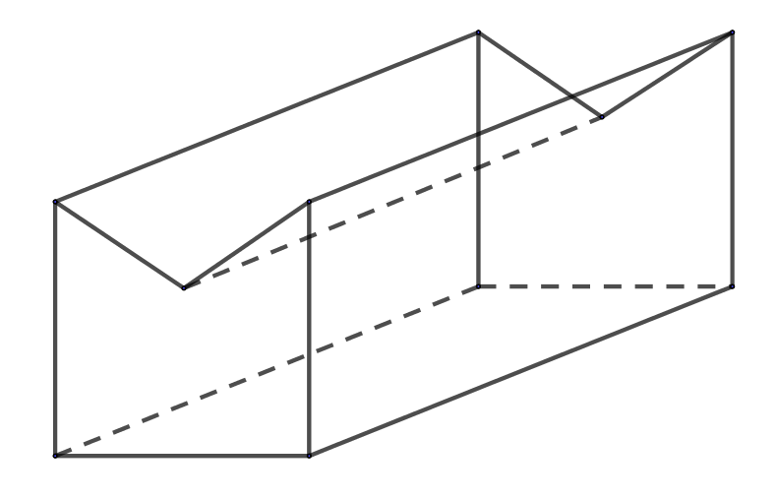 | B1 – hidden lines  B1 – full lines  B1 – complete figure
10 | $$\frac{3\left(a+b\right)-2(2a-b)}{6}$$  $$\frac{3a+3b-4a+2b}{6}$$  $$⟹\frac{-a+5b}{6}$$ | M1  M1  A1
11 | $$UK pounds → Ksh$$  $$126000×132.92=Sh. 16 747 920$$  After spending  Balance $⟹0.5×16 747 920=Sh. 8 373 960$  $$Ksh→US dollar$$  $$\frac{8 373 960}{75.19 }=111 370.661$$  $$≅111 370 dollars$$ | M1  M1  M1  A1
12 | $$LCM of 36,40 and 48=2^{4}×3^{2}×5=720 sec$$  Fastest runner = $\frac{720}{36}=20 laps$  Slowest runner = $\frac{720}{48}=15 laps$  Overlapping = $20-15=5 laps$ | M1  M1  A1
13 | $$AB=-\left(2i+3j+9k\right)+\left(-5i+k\right)=-7i-3j-8k$$  $$\left|AB\right|=\sqrt{{\left(-7\right)}^{2}+{\left(-3\right)}^{2}+{\left(-8\right)}^{2}}=\sqrt{122}$$  $$\left|AB\right|=11.05 units$$ | M1  M1  A1
14 | $$N⟹\frac{15}{8}+\left(\frac{2}{3}×\frac{9}{4}\right)-\frac{7}{4}$$  $$\frac{15}{8}+\frac{3}{2}-\frac{7}{4}=\frac{13}{8}$$  $$D⟹\frac{8}{5}-\left(\frac{9}{2}×\frac{5}{9}\right)+\frac{4}{3}$$  $$\frac{8}{5}-\frac{5}{2}+\frac{4}{3}=\frac{13}{30}$$  $$\frac{N}{D}⟹\frac{13}{8}÷\frac{13}{30}=3\frac{3}{4}$$ | M1  M1  A1
15 | $$N⟹12x^{2}-16x=4x(3x-4)$$  $$D⟹20-11x-3x^{2}=(5+x)(4-3x)$$  $$\frac{N}{D}⟹\frac{4x\left(3x-4\right)}{\left(5+x\right)\left(4-3x\right)}=-\frac{4x}{5+x}$$ | M1  M1  A1
16 | $$\tan{A=\frac{12}{5} and\sin{A=\frac{12}{13}}}$$  $$2\left(\frac{12}{5}\right)+3\left(\frac{12}{13}\right)=7\frac{37}{65}$$ | M1  M1 A1
17 | 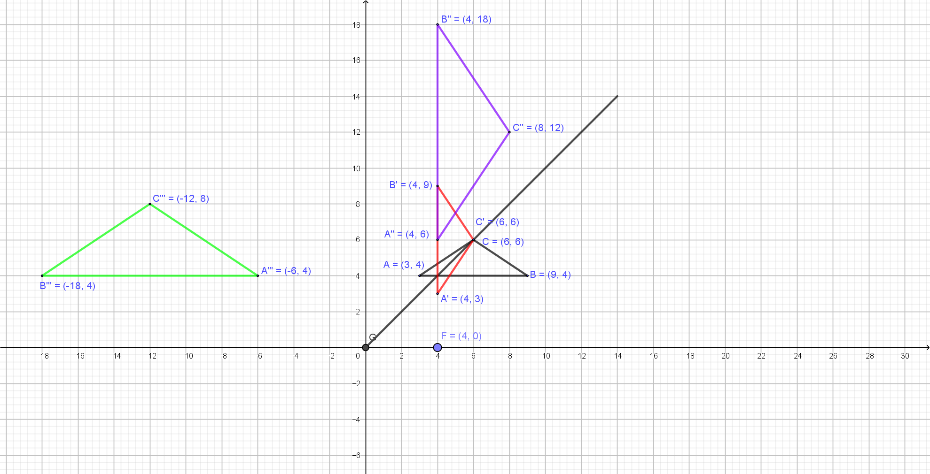 | B1 – for $∆ABC$  B1 - $y=x$  B1 -$∆A'B'C'$  B2 – enlargement  B1 - -$∆A''B''C''$  B1 – coordinates  B1 –rotation  B1 - $∆A^{'''}B^{'''}C^{''''}$  B1 - coordinates
18 | - Deposit $=0.75×5 800 000=Sh. 4 350 000$  $$Mark= \frac{5}{10}×4 350 000=Sh. 2 175 000$$  $$Nashon=\frac{3}{10}×4 350 000=Sh. 1 305 000$$  $$Nyongesa=\frac{2}{10}×4 350 000=Sh. 870 000$$ | M1 A1  B1  B1  B1
18 | - Processing fee = $0.05×5 800 000=sh. 290 000$  Total fees = $290 000+5 800 000=Sh. 6 090 000$ | M1  M1 A1
18 | - Nashon paid = $1 305 000+\left(\frac{3}{10}×1 740 000\right)=Sh. 1 327 000$ | M1 A1
19 | - (i) $\overline{x}=\frac{\sum{fx}}{\sum{f}}$  $=\frac{625}{50}$  $=12.5 cm$  (ii) median = $10.5+\left(\frac{25-18}{15}\right)×4$  $=10.5+1.87$  $=12.37 cm$  - Frequency polygon  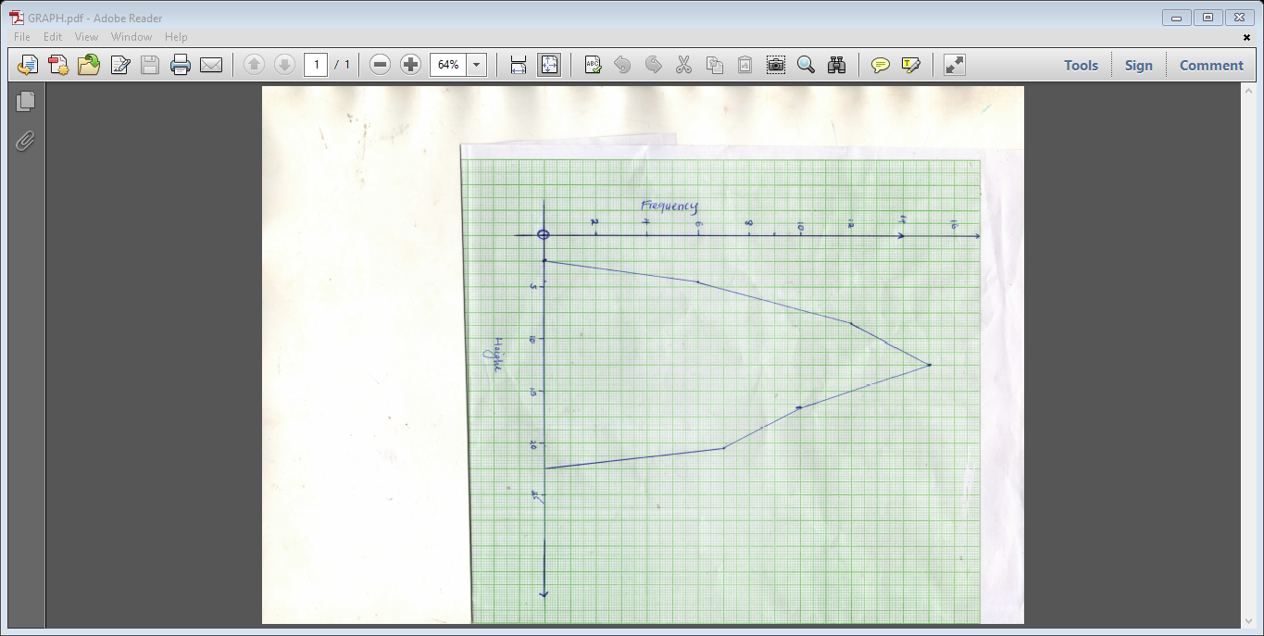 | B1 – class  B1 – frequency  B1- $fx$ row  M1  A1  M1  M1  A1
  Class | $$3-6$$ | $$7-10$$ | $$11-14$$ | $$15-18$$ | $$19-22$$
  Frequency | 6 | 12 | 15 | 10 | 7
  $$fx$$ | 27 | 102 | 187.5 | 165 | 143.5
20 | - Gradient of AB = $\frac{1-6}{4-6}=\frac{5}{2}$  $$\frac{5}{2}=\frac{y-1}{x-4}$$  $$5\left(x-4\right)=2\left(y-1\right)$$  $$5x-2y=18$$ | M1  M1  A1
20 | - Mid point of AB = $\left(\frac{6+4}{2}, \frac{6+1}{2}\right)=\left(5, 3.5\right)$ | M1 A1
20 | - $-\frac{2}{5}=\frac{y-3.5}{x-5}$  $$-2\left(x-5\right)=5\left(y-3.5\right)$$  $$y=-\frac{2}{5}x+\frac{11}{2}$$ | M1 M1  A1
20 | - $y=\frac{5}{2}x-9$  When $x=0$  $$y=\frac{5}{2}\left(0\right)-9$$  $$y=-9$$ | M1  A1
21 | - $\frac{15}{10}=\frac{28+x}{x}$  $$15x=280+10x$$  $$x=56 cm$$  Volume $=\frac{1}{3}×\frac{22}{7}\left({(15}^{2}×84)-({10}^{2}×56)\right)$  $=13 933.33 cm^{3}$  $$Volume of litres=13 933.3÷1 000$$  $=13.93 litres$  - Curved Surface Area = $\left(\frac{22}{7}×15×85.33\right)-\left(\frac{22}{7}×10×56.89\right)$  $$=2 234.73 cm^{2}$$  $$T.S.A=2234.73+\left(\frac{22}{7}×{15}^{2}\right)+\left(\frac{22}{7}×{10}^{2}\right)=3256.16 cm^{2}$$  $$⇒1.1×3256.16×100$$  $$=358 177.6 cm^{2}$$ | M1  M1  A1  M1  A1  M1  A1  M1  M1  A1
22 | - (i) Distance = $60×\frac{40}{60}=40 km$  (ii) Relative speed = $80-60=20 km/h$  Time taken $=40÷20=2hrs$  Distance covered by matatu = $2×80=160 km$  (iii) Time $=2.00 p.m+2 hrs=4:00 p.m$ | M1 A1  M1  M1  A1  M1 A1
22 | - Relative speed = $40+80=120 km/h$  Time taken $=\frac{400}{120}=3h 20 mins$  Time of the day $=2:00 p.m+3h 20 mins=5:20 p.m$ | M1  M1  A1
23 | (i) (a) $\left(40×30\right)-\left(\left(40-2x\right)\left(30-2x\right)\right)$  $$-4x^{2}+140x$$  (b) $1200-140x+4x^{2}$ | M1  A1  B1
23 | (ii) $-4x^{2}+140x=2\left(1200-140x+4x^{2}\right)$  $12x^{2}-140x+2400=0$  $x=27.81 m or 7.19 m$ | M1  M1  A1
23 | (iii) $L=40-2\left(7.19\right)=25.62 m$  $W=30-2\left(7.19\right)=15.62 m$  P = $2\left(25.62+15.62\right)=82.48 m$ | B1  M1 A1
24 | (a) (i) ${AC}^{2}={12}^{2}+9^{2}-\left(2×9×12×\cos{80}\right)=13.8 cm$  (ii) $\frac{13.8}{\sin{40}}=\frac{DC}{\sin{70}}$  $DC=\frac{13.8×\sin{70}}{\sin{40}}=20.2 cm$  (iii) $\frac{9}{\sin{A}}=\frac{13.8}{\sin{80}}$  $A=\sin^{-1}\left(\frac{9×\sin{80}}{13.8}\right)=40°$  Angle BAD = $40+70=110°$ | M1 A1  M1  A1  M1  M1  A1
24 | (b) $A=\left(\frac{1}{2}×12×9×\sin{80}\right)+\left(\frac{1}{2}×20.2×20.2×\sin{40}\right)$  $=53.2+131.1=184.3 cm^{2}$ | M1  M1 A1

